**Short Instructions:**

**Note: It is much easier to complete this task if you first look through the example segmentations below.** The “More Instructions” section contains additional written instructions and examples of good and bad segmentations.

**Examples**

Each example shows a good segmentation and one or more bad segmentations for the same image. Pay attention to the circled regions in order to see and understand the differences between good and bad segmentations.

**Example 1**

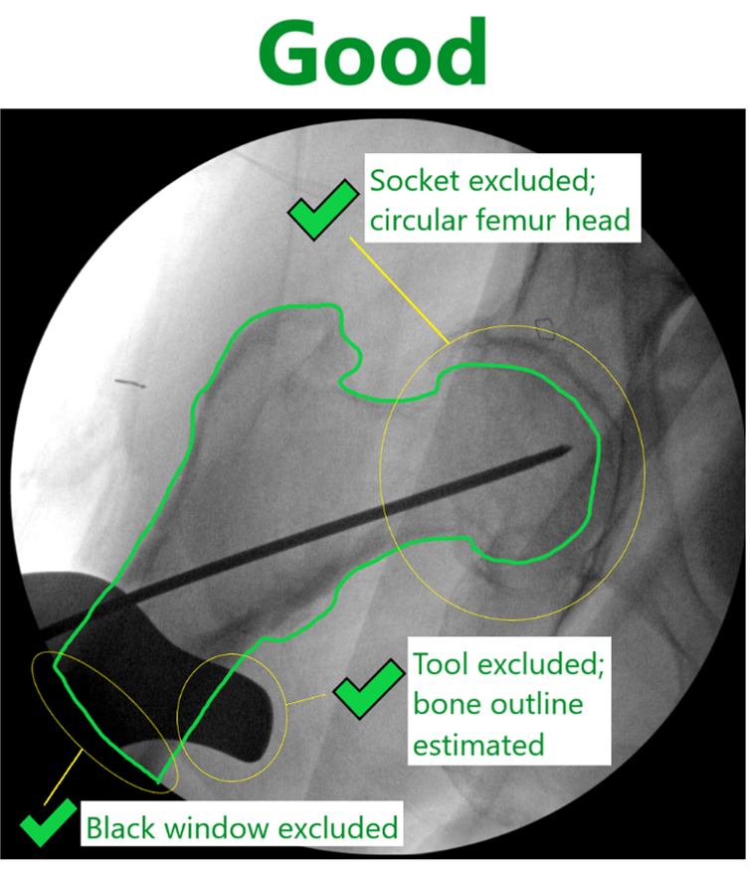 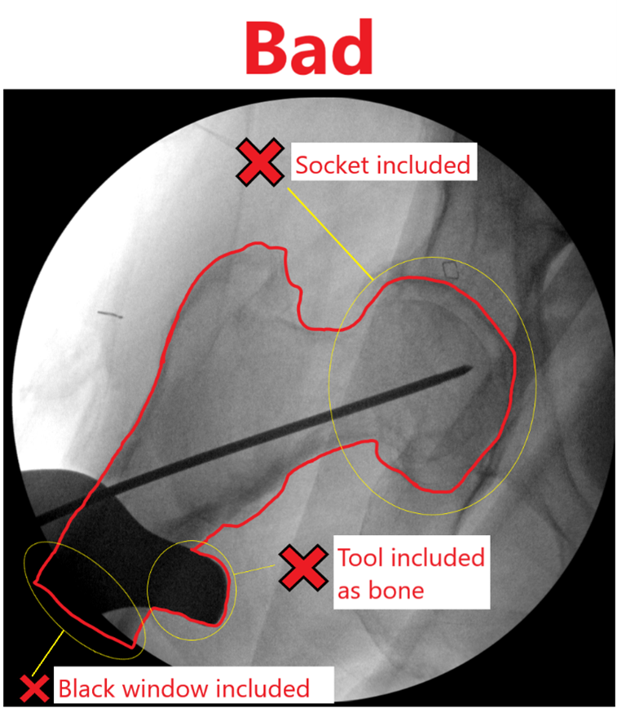

**Example 2**

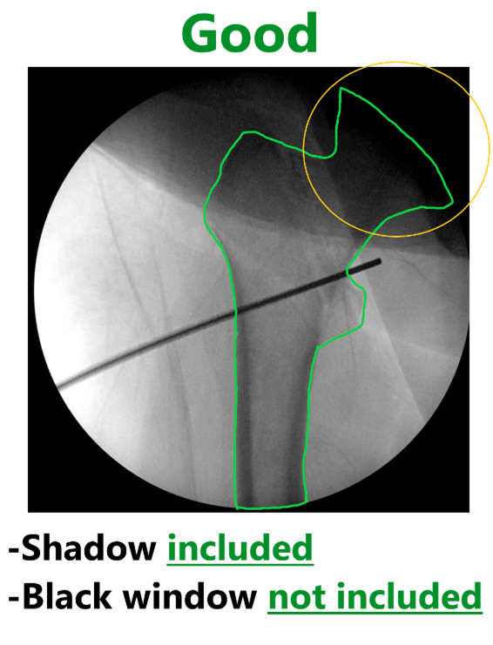  
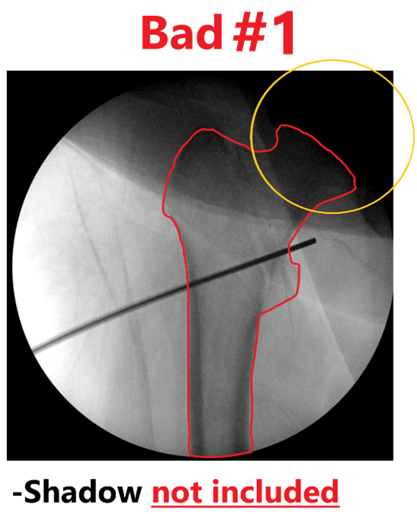  
  
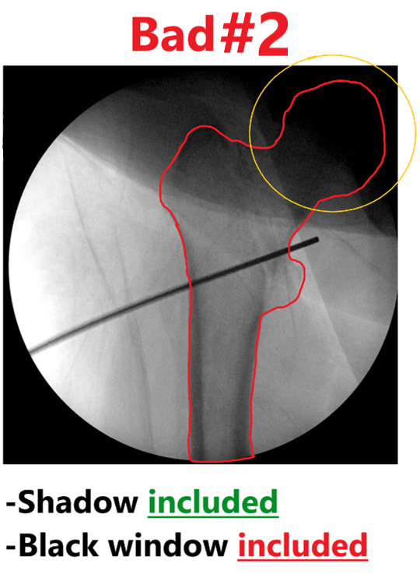

**Example 3**

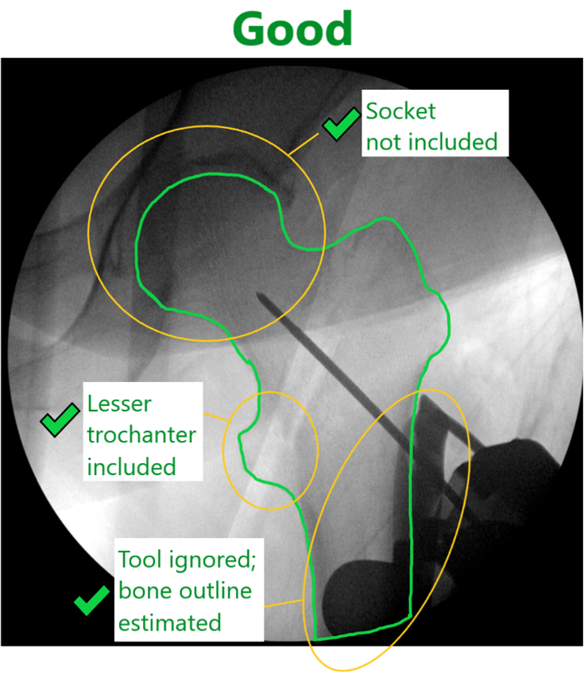 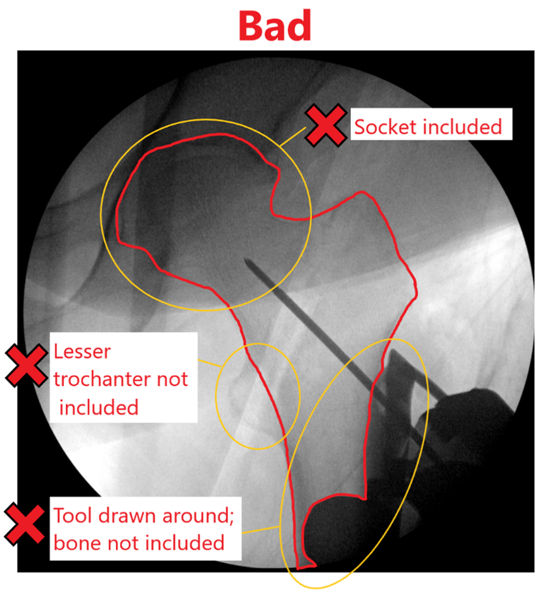

**More Instructions:**

* Be especially careful to correctly outline the femur head ("ball"). A common mistake is to include the acetabulum ("socket").
* Ignore any obstructions (objects in the way of the view of the femur) from tools, surgical wires, and shadows when determining the outline of the femur. In the case of a large obstruction (most commonly from a tool), do your best to estimate the outline of the femur.
* Never include parts of the black window/background outside of the circular view, even when estimating near an obstruction.

This semantic segmentation task requires you to segment the femur bone from front and back X-ray views of the pelvis. It is useful to have a basic understanding of the anatomy of the pelvis, especially the "ball and socket" structure of the femur head (the "ball") and the acetabulum (the "socket").

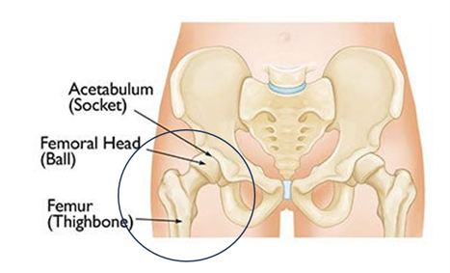

The image above shows a cartoon of a pelvis. The circled region is approximately the area shown in the dataset's images. Below is a diagram with a more detailed anatomy of the femur bone itself showing front and back views.

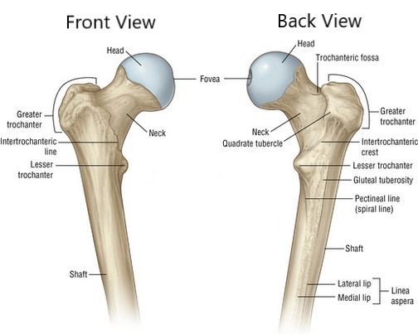

**Note: Your segmentation submissions will be graded. Your accuracy on this task will help the advancement of better medical care. Good performers may be invited back to do more segmentations with the potential for higher pay.**

**Additional Examples**

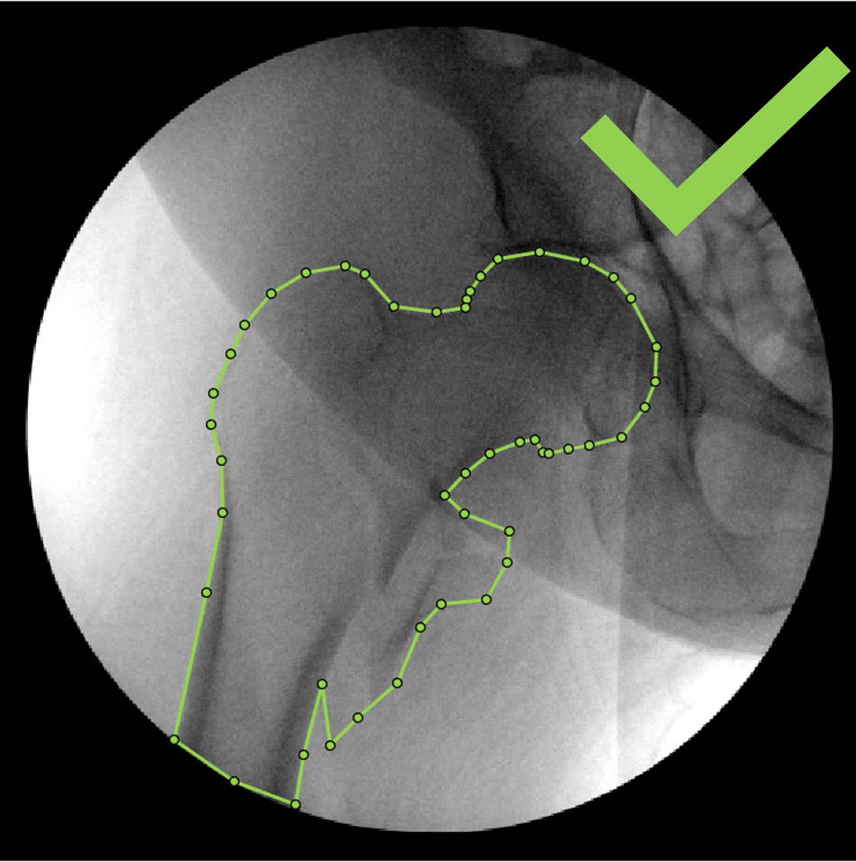 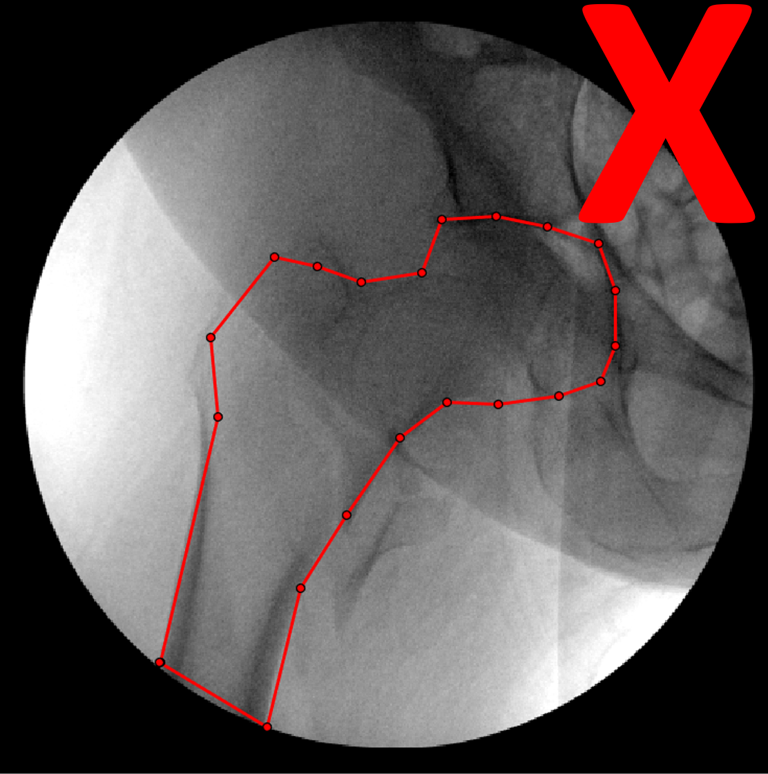  
  
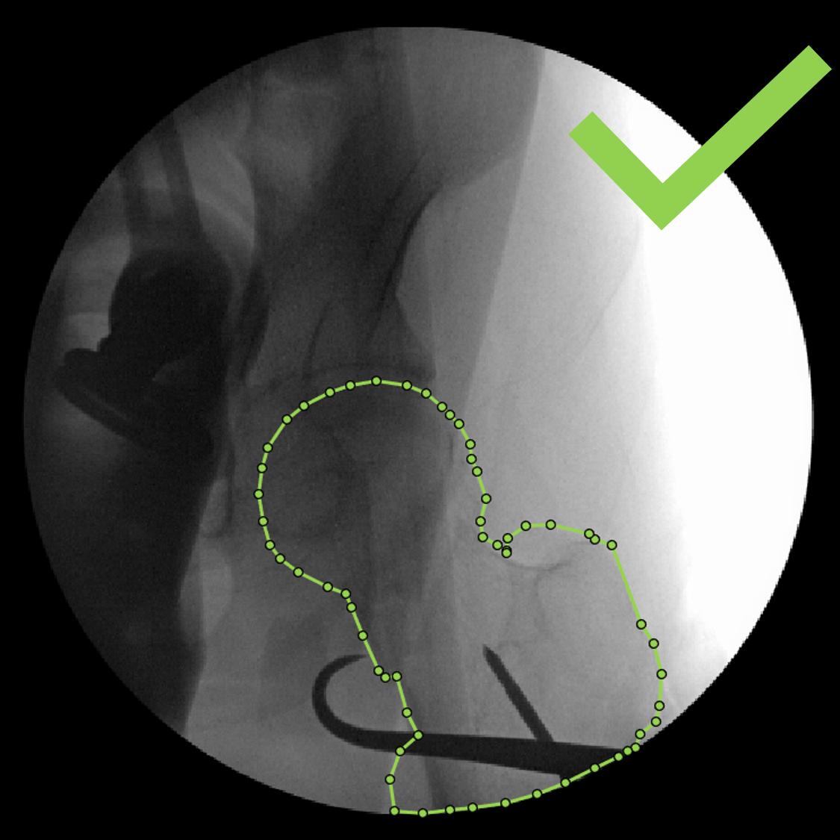 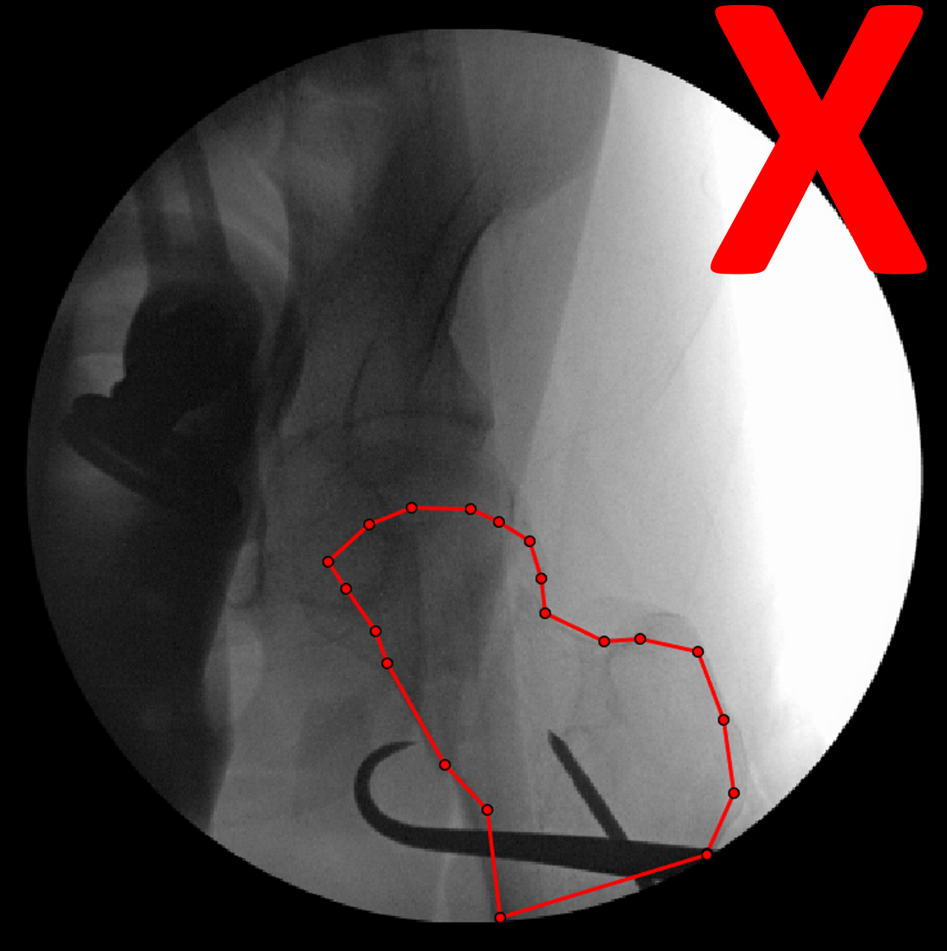

**Original Examples in Larger Size**

